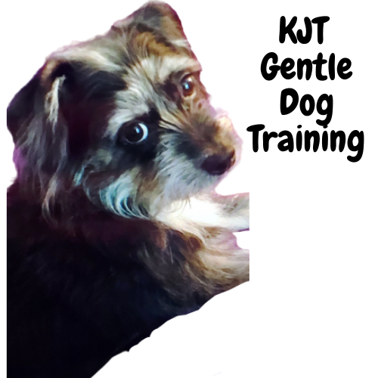
C
Creating an unbreakable bond between owners and their beloved dogs for years to come.
Dog Training Services Agreement

This Agreement between __________________________ (hereinafter referred to as “Client”) and
KJT Gentle Dog Training (hereinafter known as “Trainer”) pertains to the following:

Client’s Dog (Name):
(hereinafter referred to as “Dog”)

_____________________Breed: __________________AGE:________Color:_______________

For good and valuable consideration, the parties agree as follows:

Training Fees:

- Client agrees to pay Trainer a nonrefundable fee in the amount of $_____ for the first session. (approximate length_____________ and $__________.for each follow-up session (approximate length__________) OR
- Client agrees to pay Trainer a nonrefundable fee in the amount of $_______for a package of ____sessions (approximate length___ _____ each) to be paid at first session. All sessions must be completed within 180 days of commencement of contract, or they will be forfeited.
- Client agrees to pay travel of $ ______for sessions beyond 20-mile radius of our home office.
- Payment is due the first of each month. (_____________) or as decided at initial meeting.

Services: Trainer agrees to provide private lessons for Client and Dog on a lesson-by-lesson basis, the goal being to teach Client how to train and work with Dog. These lessons will take place at Client’s home. Trainer will make every reasonable effort to help Client achieve training and behavior modification goals but makes no guarantee of Dog’s performance or behavior as a result of providing professional animal behavior consultation. Client understands that he/she and members of the household must follow Trainer’s instructions without modification, work with dog daily as recommended, and constantly reinforce training being given to Dog.

Cancellation Policy: If Client fails to give at least 24-hour cancellation notice, or is not present at time of scheduled appointment, session fees are still due. For a package deal, the session will still be counted as one session.

KJT Gentle Dog Training

Liability: If Dog causes property damage, or bites or injures any dog, animal, or person (including but not limited to Trainer and Trainer’s agents), during or after the term of this Agreement, then Client agrees to pay all resulting losses and damages suffered or incurred, and to defend an indemnify Trainer and Trainer’s agents from any resulting claims, demands, lawsuits, losses, costs, or expenses, including attorney fees. If Dog is injured in a fight or in any other manner during or after the term of the Agreement, Client assumes the risk and agrees that Trainer should not be held responsible for any resulting injuries losses, damages, costs or expenses.

At Trainer’s sole election Trainer’s duties hereunder shall terminate if (a)in Trainer’s sole judgment Dog is dangerous or vicious to Trainer or any other person or animal, or interferes with the training of other dogs, or (b)Client breaches any term or condition of this Agreement. Upon termination in accordance with the foregoing Trainer’s duties shall terminate but all other provisions of the Agreement shall continue in full force and effect.

This agreement is binding upon Client, spouse of Client, and children of Client. This Agreement supersedes all prior discussions, representation warranties and agreements of the parties, and expresses the entire agreement between Client and Trainer regarding the matters described above.

The parties confirm that, except for that which is specifically written in this Agreement, no promises, representations, or oral understandings have been made, regarding Dog or anything else. Without limiting the generality of the foregoing, Client acknowledges that Trainer has not represented, promised, guaranteed, or warranted that Dog will not be dangerous or vicious in the future, that Dog will not exhibit other behavioral problems, or that the results of the training will last for any particular amount of time. This agreement may be amended only by a written instrument signed by both Client and Trainer.

Executed on this ___________day of _______________; 20_____

Trainer:

Kelly Fleming/KJT Gentle Dog Training ____________________________
(printed name): (signature):

Client:

_______________________ _____________________________
(printed name): (signature):

